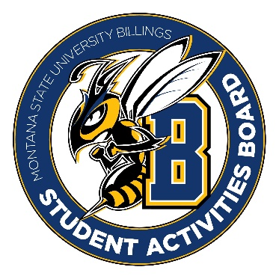

Student Activities Board

General Meeting
  - Meeting Summary

Date/Time of Meeting | Date: 4/06/2026 Time: 5:55
Location of Meeting | SAB room
Members Present | Kaelyn, Taylor, Thomas, Alia, Izabella, Seth, Aspen, Chloe
Members Absent | Kennedy
Guests
Minutes Issued | 5:55-6:27

  - ANNOUNCEMENTS:
- TEAM OUTING: Friday 24th @ 7:00 bowling and pizza. Bowling place TBD
- Reminder: All executive positions are open. Please submit an application if you would like to apply for one of the executive positions.
- Please continue to spread the word that SAB is always in need of general members. We want to grow the club and have more people involved!
Next Event
Event Name | Discussion
- Registration Royal (April 7th)  - 6:00-8:00  - Be here at 5:45. | - We have prizes for this event.
- Karaoke (April 8th)  - 6:00-8:00 in Sub Atrium  - Be here at 5:30 | - Iced tea, lemonade, and water.  - Popcorn bar
- Leadership Award Dinner (15th)  - 5:30 | - EVERYONE PLEASE BE THERE!!!
- Summer Send-Off (April 16th)  - More to come for this event!  - 3:00? | - Tye Dye event (shirts and bucket hats)  - Food truck (corn dog truck)/Ice cream truck  - Yard Games
- Summer Send-Off CC (21st)  - We are going to try to shoot for the 21st from 12-2 | - Maybe we can do a snow cone truck or ice cream truck  - Bring some yard games possibly
- CRAM JAM (April 27th)  - 8:00-9:30 | - BINGO  - We need Prizes! Taylor is ordering from Amazon.  - Let her know if you have any ideas.

Other items talked about:
- July 13th and 14th is Orientation. Please show up and help Taylor with SAB stuff for orientation.

