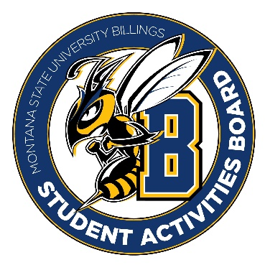

Student Activities Board

General Meeting
  - Meeting Summary

Date/Time of Meeting | Date: 4/13/2026 Time: 6:00-
Location of Meeting | SAB room
Members Present | Kaelyn, Taylor, Izabella, Seth, Aspen, Chloe, Kennedy
Members Absent | Thomas, Alia, Aspen
Guests
Minutes Issued | 6:00-6:25

  - ANNOUNCEMENTS:
- Student Leadership Dinner is this Wednesday at 5:30. You are expected to be there!
- TEAM OUTING: Friday 24th from 7:00-8:00 Axe Throwing. Think of ideas for dinner after the event. (Mckenzie River?) Please meet here at 6:30 if you need a ride.
Next Event
Event Name | Discussion
- Leadership Award Dinner (15th)  - 5:30  - Meet in Glacier | - EVERYONE PLEASE BE THERE!!!
- Summer Send-Off (April 16th)  - 3:00-5:00  - Sub Lawn  - Be in the Sab room by 2:00!! | - Tye Dye event (shirts and bucket hats)  - Food truck (corn dog truck)/Ice cream truck (we will do a ticket system to ensure they are a student)  - Yard Games
- Summer Send-Off CC (21st)  - 12:00-2:00  - Be in the Sab room by 11:00! | - Maybe we can do a snow cone truck or ice cream truck  - Bring some yard games possibly
- CRAM JAM (April 27th)  - 8:00-9:30  - Meet here at 7:30 | - BINGO  - We need Prizes! Taylor is ordering from Amazon.  - Let her know if you have any ideas.

Karaoke RECAP:
Roughly 37 people (most people came for the popcorn bar and drinks)
Pros:
- Popcorn Bar was a hit!!!!!
- The tea was a hit.
Cons:
- Nobody really did karaoke.
Other items talked about:
- July 13th and 14th is Orientation. Please show up and help Taylor with SAB stuff for orientation.

