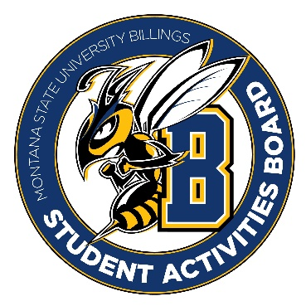

Student Activities Board

General Meeting
  - Meeting Summary

Date/Time of Meeting | Date: 12/01/2025 Time: 6:00
Location of Meeting | SAB room
Members Present | Taylor, Kaelyn, Thomas, Alia, Kennedy, Chloe, Isabella, Aspen, Brendan
Members Absent
Guests
Minutes Issued | 6:00-6:31

  - ANNOUNCEMENTS:
- No Meeting Monday 8th but we have an event!!
- Taylor and Kennedy are going shopping at 11 tomorrow
Old Business
Event Name | What went well | What to do differently
Friendsgiving | - The friendship bracelets and coloring were a hit.  - Over 40 people, maybe 60. | - Non-dairy options  - Better marketing for free food  - The marketing was at the last minute. Having marketing out earlier would have been better
Rodeo Registration | - The mechanical bull was a hit.  - The event brought in several people and the games were a hit.  - It was communicated well.

Next Event
Event Name | Discussion
Cookie decorating event  - December 4th from 6-8 in Glacier | - Cookies decorating  - Its open to students, staff, and faculty.  - There will be two prizes. One will be for the best decorated cookie and the other for a student who filled out the survey.
Cram Jam  - December 8th from 7-9 | - Bingo and prizes  - We will need to find a few smaller prizes.  - Taylor will get more details on this and post it in BAND
  - Other Information:
- We are going to start doing surveys at our events to help collect attendance, get feedback on the event, and get information on the students and their preferences (are they on or off campus, are their classes at city college or the campus).
- NACA went well there is a pile of information on the table by the couch if anyone is interested in looking at them.
- The executive positions will be announced tomorrow!
- We will start planning for welcome week for next semester. We will keep you updated on this event.

