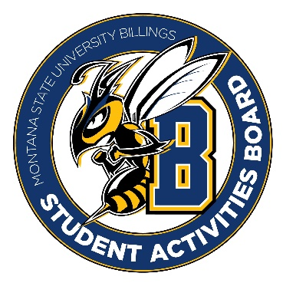

Student Activities Board

General Meeting
  - Meeting Summary

Date/Time of Meeting | Date: 11/17/2025 Time: 6:02
Location of Meeting | SAB room
Members Present | Taylor, Kaelyn, Thomas, Alia, Kennedy, Chloe, Isabella
Members Absent | Aspen, Brendan
Guests
Minutes Issued | 6:02-6:24

  - ANNOUNCEMENTS:
- No Meeting Monday 24th! Enjoy your Thanksgiving break.
Old Business: Crafts and Questions
What went well: | What needs to be changed:
- Giving out prizes (it brought in more people when they found out they could win things)  - Lego prizes were a big hit | - New acrylic paints  - Overlapped with other activities.  - Water-color paint was not as big of a hit

Next Event
Event Name | Discussion
City College Pop-up Event  - November 19th 11-1 | - Coloring pages  - Pop-dart games
Friendsgiving  - November 19th from 5-7  - Be here at 4:30 | - Please come and help with this event!  - We are providing drinks and desserts.
Registration Rodeo  - November 20th from 6-9  - Be here at 5:45 | - You can ride the bull if you want.  - Tabeling for the most part.
Cookie decorating event  - December 4th from 6-8 in Glacier | - Cookies and ornament decorating
Cram Jam  - December 8th | - Bingo and prizes
  - Other Information:
- Opening executive positions! There will be an opening for the marketing position and the vice president position. If interested send Taylor an email about why you are interested, your goals, and why we should choose you.
- Marketing is 3hrs/week, and vice chair is 5hrs/week ($11 per hour for both positions)

