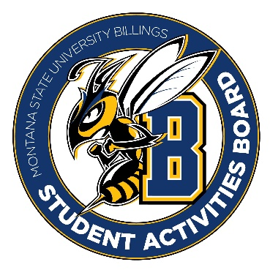

Student Activities Board

General Meeting
  - Meeting Summary

Date/Time of Meeting | Date: 11/10/2025 Time: 6:04
Location of Meeting | SAB room
Members Present | Taylor, Kaelyn, Thomas, Alia, Kennedy, Chloe, Aspen
Members Absent | DiDi, Brendan, Isabella
Guests
Minutes Issued | 6:04-6:30

  - ANNOUNCEMENTS:
- NO Classes tomorrow and offices are closed!
- No craft circle tomorrow.
Next Event
Event Name | Discussion
General Lead Event  - November 12th: 6-8 pm SUB ATRIUM  - Be here at 5:30 to start setting up | - Trivia and craft night (Crafts and Questions)  - Kahoot (movie category, Disney, music)  - Watercolor painting/canvas painting  - Bracelet making
City College Pop-up November 19th  - 11-1 | - Pop Darts  - Coloring/Beading
Friendsgiving  - November 19th from 5-7 | - Please come and help with this event!
Registration Rodeo  - November 20th from 6-9 | - Please come and help with this event!!  - You can ride the bull if you want.  - Tabeling for the most part.

  - Other Information:
- Those going to NACA will be gone on the 19th through the 23rd
- Candle Lighting Ceremony/Cookie decorating December 24th (More to come on this event)
- Cram Jam is the 8th (first day of finals week). It will be from 7-9 we will be putting on BINGO with prizes. BREAKFAST for Dinner
- Love N stuff is coming up for Valentines Day. This is our biggest event and is “sold” out every year. Please be prepared to help at this event! We will all get to make one to keep!

