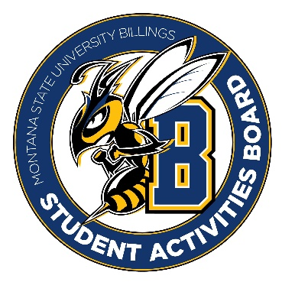

Student Activities Board

General Meeting
  - Meeting Summary

Date/Time of Meeting | Date: 10/27/2025 Time: 6:01
Location of Meeting | SAB room
Members Present | Taylor, Kaelyn, Thomas, Brendan, Isabella, Alia, Kennedy, Chloe, DiDi
Members Absent | Aspen
Guests
Minutes Issued | 6:01-6:32

  - ANNOUNCEMENTS:
- Check-in: please know that the entire SAB team is here for you if you ever need any help. We are here for you whether it be school related or outside of school.
- If everyone can do a board today that would be great
- Craft circle from 2-3 tomorrow 10/28
- During our meeting next week, we would like to do a board game night for just SAB members for team bonding.
Next Event
Event Name | Discussion
Halloween Event  - 10/29/2025  - 6-9  - Please be here at 5 to help set it up! | - From 6-7 there will be a costume concert in Petro area.  - There will be a dance from 7-9 in the Petro area.
City College Event  - 29th from 11-1 | - The goal is to get some students from city college to come to the main event that night.
General Lead Event  - November 12th: 6-8 pm | - Trivia and craft night  - Think of a name for the event as well as snacks/drinks.
  - Other Information:
- NACA tickets are bought (Taylor, Brendan, Alia, and Thomas will be going)
- For those not going to NACA we have Friendsgiving and registration rodeo that week that we will need to be at. (Please try to make both events, but at least one is mandatory).

