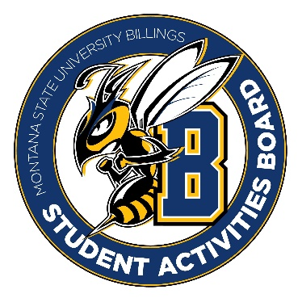

Student Activities Board

General Meeting
  - Meeting Summary

Date/Time of Meeting | Date: 10/20/2025 Time: 6:07
Location of Meeting | SAB room
Members Present | Taylor, Kaelyn, Aspen, Thomas, Brendan, Isabella, Alia,
Members Absent | Kennedy, DiDi, Chloe
Guests
Minutes Issued | 6:07-6:20

  - ANNOUNCEMENTS:
- We expect that everyone be at events on time unless approved by Taylor or Kennedy.
- Please clean up after yourselves. Put items back where you found them, they do not belong on the floor.
- We are going to go to Shamrock on Wednesday at 3:00 to get snacks/drinks for karaoke. We will also be looking to get decorations for the Halloween event.
- City College Pop-up event on the 29th from 11-1. Please come if you can!
Next Event
Event Name | Discussion
Karaoke Night  - 10/22/2025  - 6-8  - Be in the room at 5:45 | - We are going to go to Shamrock at 3:00 on Wednesday to get snacks and drinks.
Halloween Event  - 10/29/2025  - 6-9  - Please be here at 5 to help set it up! | - From 6-7 there will be a costume concert (location tba)  - There will be a dance from 7-9 at Glacier.
City College Event  - 29th from 11-1 | - The goal is to get some students from city college to come to the main event that night.

  - Other Information:
- There will be a general lead event on November 12th. You guys are in charge of figuring out the event (this means coming up with an event idea, creating promo, and all other details). You guys will need to meet and come up with an idea to present to us in the next meeting on 11/3/2025.
- CONGRATULATIONS to Alia and Thomas for being chosen to go to NACA. Please understand that we have a budget and wish we could take everyone, but unfortunately that is unrealistic. Our decision was tough, and we want to know we think highly of you all!
- FUTURE EVENTS: Friendsgiving November 21st, cookie decorating December 3rd, CRAM JAM is on December 8th (we will be holding BINGO in the cafeteria). These are tentative dates and may change!!
- We were thinking of doing a game night with ASMSUB for team bonding.

