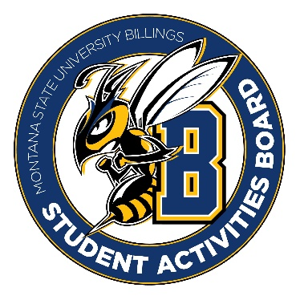

Student Activities Board

General Meeting
  - Meeting Summary

Date/Time of Meeting | Date: 02/023/2026 Time: 6:00
Location of Meeting | SAB room
Members Present | Kaelyn, Taylor, Thomas, Kennedy, Alia, Izabella, Chloe, Seth
Members Absent | Aspen
Guests
Minutes Issued | 6:00-6:45

  - ANNOUNCEMENTS:
- We need to come up with a team event to do. This can be dinner or something like an escape room. Let’s start thinking about dates and times so we can get something planned that works for everyone.
- Positions for executive members are open. Anyone can apply!! Also, if you know anyone who wants to be a general member spread the word.
- Please RSVP for the student leadership awards. They should be in your email!
Next Event
Event Name | Discussion
- BINGO (3/26/26)  - 6:00 – 8:00  - Stingers  - Be here at 5:30!! | - There will be lots of prizes  - Snacks and Drinks will be provided

Other items talked about:
- Please start by coming up with a list of events you would like to see next year. Taylor needs this by the meeting next week.
- Ideas: jeopardy, price is right, game shows, hypnotist, magician, button making event, vision boards, karaoke, open mic, tie die event
- We need to get prizes for registration royal. Please start thinking about prizes we should get for this event. This is on April 7th from 6-8 in Glacier.
- Lego Set, dorm survival kits, summer baskets
- Swag Items for promo of SAB. Think of ideas!!
- Tote bags, buttons, stickers, magnets, Carabiner, knock off Stanleys, to go coffee cups (with a lid), scrunchies
- Summer Send off is April 16th. We have to start getting ideas for this event ASAP!!!
- Outdoor events if it is nice, tie die event, food trucks, etc.

