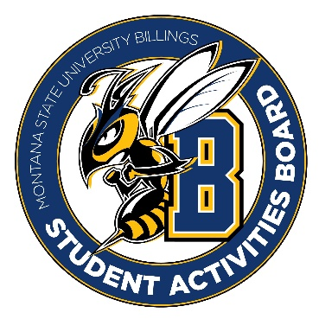

Student Activities Board

General Meeting
  - Meeting Summary

Date/Time of Meeting | Date: 02/09/2026 Time: 6:02
Location of Meeting | SAB room
Members Present | Kaelyn, Taylor, Thomas, Kennedy, Alia, Izabella, Aspen
Members Absent | Chloe
Guests
Minutes Issued | 6:02-6:43

  - ANNOUNCEMENTS:
- We are going to go shopping at 12:00 tomorrow to get snacks for open mic night as well as crafts for city college.
- We will need to get the craft bags made before Thursday for the city college event on Thursday. We will make these bags either Tuesday evening or sometime on Wednesday.
Love N Stuff Event Recap:
- We had 245 students attend the event on campus and 155 students at the city college.
PROS:
- The photo booth was a hit. Students loved taking pictures with their friends and their stuffed animals.
- Clean up went smoothly. The people who stayed on top of cleaning during the event made the clean-up process better.

CONS/Revisions:
- We need a better system for ensuring that each student only gets one animal. We also need proof that they are students here (check their ID card or Get App?) (an X on the hand after they get an animal).
- We need to order more food next time. The food went quickly
- The music needs to be better planned. There needs to be a set playlist, and we need to set the music up earlier so that we can solve problems that may arise.
- We should find a new place to set up an example of animals so that people can see what they look like.
- On promo next time lets ensure that it says students must bring their student ID and be present to stuff an animal.

Next Event
Event Name | Discussion
- Open mic event  - February 25th @ 6:00 – 8:00 | - We will provide snacks and drinks at this event.
- City college craft bags  - February 26th @ 11:00 | - We will make the craft bags in advance so that students can either take on to go or sit and do it there.
- General Led Event  - Week after spring break | - This is up to the general members to figure out  - Please figure out the time and location ASAP so we can book the room.
- Saint Patrick’s Day  - Week of the 17th | - We might plan an event for this week.  - More to come on this!!
- Comedian/Performer  - Week of the 23rd | - Think of some ideas.  - More to come on this!

Other items talked about:
- All executive positions will be open to apply for next year. If your interested in being in an executive position or knowing someone who is, please apply. General members are needed!!!
- Student Leadership Awards: nominate someone who you think deserves this award. Please make sure to take time and fill it out well, people actually read these. We would love to see someone we know nominated for this award. Everyone who is nominated or nominates someone gets to go to dinner. DUE by March 9th.

