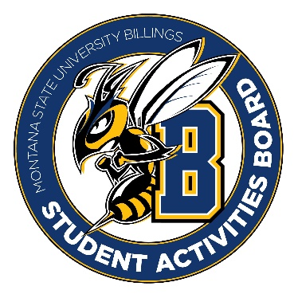

Student Activities Board

General Meeting
  - Meeting Summary

Date/Time of Meeting | Date: 03/30/2026 Time: 6:00
Location of Meeting | SAB room
Members Present | Kaelyn, Taylor, Thomas, Kennedy, Alia, Izabella, Seth, Aspen
Members Absent | Chloe
Guests
Minutes Issued | 6:00-7:00

  - ANNOUNCEMENTS:
- No event this week! Mini Spring Break Thursday – Sunday.
- We need to come up with a team event to do. This can be dinner or something like an escape room. Let’s start thinking about dates and times so we can get something planned that works for everyone.
Next Event
Event Name | Discussion
- Registration Royal (April 7th)  - 6:00-8:00  - We will go shopping the 6th @ 4:00. | - We need to get prizes for this event.  - Motivation basket (snacks, drinks, mini games)  - Legos, multi-charging chords, calculator, campus store item
- Karaoke (April 8th)  - 6:00-8:00 in Sub Atrium | - We were thinking of iced tea, lemonade, and water.  - Maybe a popcorn bar
- Leadership Award Dinner (15th)  - 5:30 | - EVERYONE PLEASE BE THERE!!!
- Summer Send-Off (April 16th)  - More to come for this event!  - 3:00?? | - Tye Dye event (shirts and bucket hats)  - Food truck/Ice cream truck  - Yard Games
- Summer Send-Off CC (Week of 20th)  - We are going to try to shoot for the 21st from 12-2 | - Maybe we can do a snow cone truck or ice cream truck  - Bring some yard games possibly
- CRAM JAM (April 27th)  - 8:00-9:30 | - BINGO  - We need Prizes  - Lego sets, summer basket, speaker, cooler, water bottle, fishing pole.

BINGO RECAP:
Bingo was held in Stingers. We had approximately 42 people throughout the night.
Pros:
- The brownies were a hit
- Prizes were good (stuffed animals were fun)
- The location seemed to be a good hit
Cons:
- The coffee was not a big hit
- Sugar Cookies did not go as well.
- Preplan music list
- Technical difficulties

Other items talked about:
- Reminder: All executive positions are open. Please submit an application if you would like to apply for one of the executive positions.
- Please continue to spread the word that SAB is always in need of general members. We want to grow the club and have more people involved!

