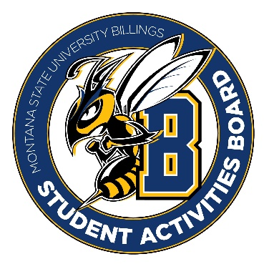

Student Activities Board

General Meeting
  - Meeting Summary

Date/Time of Meeting | Date: 03/16/2026 Time: 6:00
Location of Meeting | SAB room
Members Present | Taylor, Thomas, Kennedy, Alia, Izabella, Aspen, Chloe, Seth
Members Absent | Kaelyn
Guests
Minutes Issued | 6:00-6:44

  - ANNOUNCEMENTS:
- Please try to find some people to join SAB. FYI ALL positions are open for SAB, if you want to be an executive member, fill out the form!
- We are looking to create a new executive position that is dedicated to someone who can focus on city college events. This individual will be the one in charge of coming up with events for city college and running those events. It is preferred that this individual attends city college and knows what works best there.

  - Craft Night RECAP:
- 03/10/2026 Craft night recap- We think about 20 people attended. For next time, we think better marketing would result in a better turnout.

- City college craft kits were a success, we think about 70 kits were given out.

Next Events:
3/26/2026:
Thursday
Time: 6:00pm-8:00pm
- We think we are going to hold off on Drag Queens/Performers. We are going to plan on having a bingo night. We will need to get prizes for this event.
-The event will be in The SUB Glacier room.
- We are thinking of MSUB merch, Legos, baskets, or a coffee card to stingers, spring basket?
- We will go shopping on Friday at 1:00pm.
- We will order desserts and drinks from Sodexo: cookies, brownies, and sodas.

  - Upcoming Future Events:
- Summer Send Off UC and CC
- Cram Jam
- We plan to discuss these events at our next meeting.

