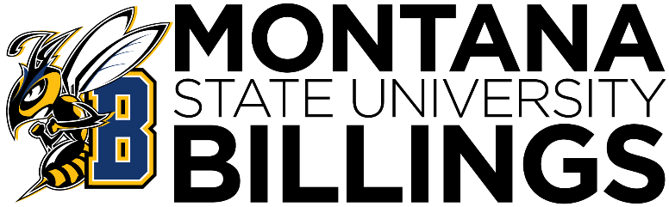

MSUB

NEW

FACULTY

GuideBOOK


Table of Contents

Welcome | 3
Acronyms | 4
State Colleges Map | 6
Tribal Colleges Map | 7
Academic Senate | 8
Academic Support Center | 9
Assessment and Accreditation | 10
Budget Office | 11
Business Services | 12
Campus Store | 13
Career and Employment Services | 14
Center for Engagement | 15
Center for Teaching and Learning | 16
Disability Support Services | 17
Financial Services and Payroll | 18
Grants and Sponsored Programs | 19
Honors | 20
Human Resources | 21
Institutional Research | 22
Information Technology | 23
Library | 24
Military and Veteran’s Success Center | 25
Montana10 | 26
Montana Center for Inclusive Education | 27
Native American Achievement Center | 28
Office of Educational Access | 29
Office of International Studies | 30
Student Health Services | 31
TRIO/Student Support Services | 32
Women’s and Gender Studies Center | 33
Women’s Faculty Caucus | 34

Welcome to MSUB

Hello Yellowjacket,

If you’re reading this, then congratulations! You’re officially a part of MSUB. The best part, we like to think, because without you we’re just a collection of buildings with a lot of confused students. Whether it’s your first time on campus, or you’re a returning alum, getting to know MSUB as it is now is a big task. To that end, we’ve compiled this helpful guidebook, introducing you to some departments you might not know, several of the many acronyms you’ll encounter, and just a little bit more.

This guidebook isn’t meant to be a complete dossier on everything you’ll find on campus, but we do hope it’ll get you started, and point you in the right direction if you’re feeling lost. Department contact information, including staff, are listed here for your quick reference, but be sure to check out the MSUB Directory ( https://www.msubillings.edu/directory/ ) for the most up-to-date information if something is out-of-date here.

We look forward to meeting you, and encourage you to reach out if you have any questions, concerns, or suggestions to help you Be U @MSUB.

Acronyms
University and State Entities:
AIMA | American Indian Minority Achievement Program
ARSA | Academic, Research and Student Affairs (Subcommittee of the Board)
BOR | Board of Regents
MSU | Montana State University (Bozeman)
MSUB | Montana State University Billings
MUS | Montana University System
OCHE | Office of the Commissioner of Higher Education
OPI | Office of Public Instruction

Evaluation and Contracts:
CBA | Collective Bargaining Agreement (Faculty)
DRTC | Department Rank and Tenure Committee
MFPE | Montana Federation of Public Employees (Classified Staff)
MSUBFA | Montana State University Billings Faculty Association
MTYCFA | Montana Two Year College Faculty Association
URTC | University Rank and Tenure Committee

Colleges:
CC | City College
CHPS | College of Health Professions and Science
CLASS | College of Liberal Arts and Social Sciences
COB | College of Business
COE | College of Education

Billings:
BSED | Big Sky Economic Development
RMC | Rocky Mountain College (Rocky)
SD2 | School District 2

Committees:
FACC | Faculty Administrative Collaborative Committee
UCC | Undergraduate Curriculum Committee

Offices:
ASC | Academic Support Center
AIO | American Indian Outreach
CFE | Center for Engagement
CTL | Center for Teaching and Learning
DSS | Disability Support Services
GSP | Grants and Sponsored Programs
IR | Institutional Research
IT | Information Technology
MCIE | Montana Center for Inclusive Education
MVSC | Military and Veterans Success Center
NAAC | Native American Achievement Center
OIS | Office of International Studies
ROTC | Reserve Officer Training Corps
SAS | Student Access and Success
SHS | Student Health Services
SSS | Student Support Services
UCAM | University Communications and Marketing
UPD | University Police Department
WGSC | Women’s and Gender Studies Center

Other:
Admin General | A campus-wide email distribution list used by administration.
D2L | Desire2Learn
EAP | Employee Assistance Program
IDC | Indirect Costs (also called F & A, Facilities and Administrative costs)
NWCCU | Northwest Commission on Colleges and Universities (Accrediting Body)

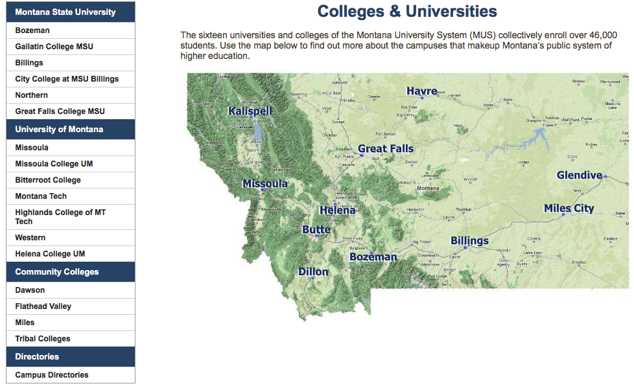
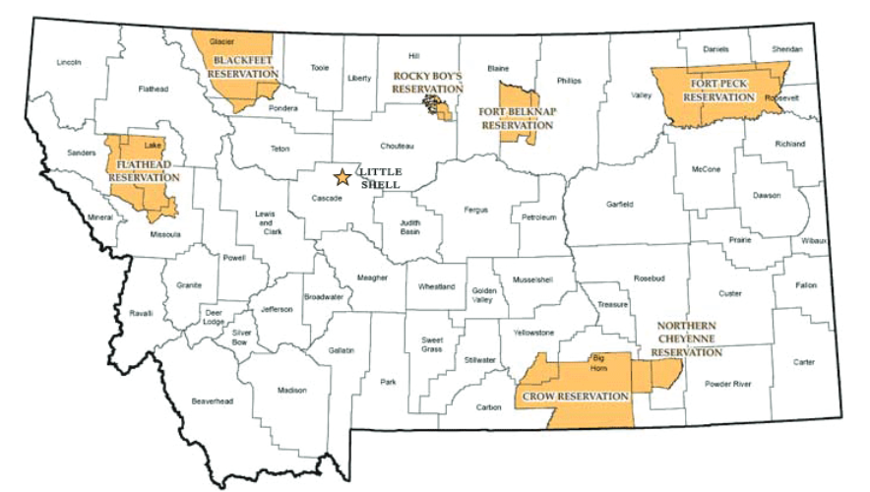

Tribal Colleges:
LBHC—Little Big Horn College, Crow
CDKC—Chief Dull Knife College, Northern Cheyenne
FPCC—Fort Peck Community College
ANC—Aaniiih Nakoda College, Fort Belknap
SCC—Stone Child College, Rocky Boy’s
BCC—Blackfeet Community College
SKC—Salish Kootenai College, Flathead

Academic Senate

Primary Functions
The Academic Senate is constituted as the highest level policy recommending body at Montana State University Billings concerned with the academic program of the institution. As such, all academic policy considerations are under the purview of the Senate. The Senate is charged with the responsibility of making recommendations to the Chancellor of MSUB on matters concerning curriculum and academic policy, degree requirements, admission and retention, the MSUB calendar, the structure of the academic programs, and other matters referred by the Chancellor of MSUB or Faculty Administration Committee.
Contact Information

- University: McM 214
- City College: N/A
- (406)657-1676
- rrabemeduna@msubillings.edu

Essential Links
- Homepage: https://www.msubillings.edu/senate/
- Intranet page includes links to CourseLeaf and How-To Videos: https://www.msubillings.edu/intranet/senate/index.htm

Staff
Rita Rabe Meduna, Administrative Support
Dr. Suzette Nynas, Chair (Professor, Department of Health Sciences & Human Performance)

ACademic Support Center (ASC)

Primary Functions
The Academic Support Center's mission is to empower students to become confident, capable, independent learners. The ASC provides qualified tutors, supplemental instruction leaders, peer mentors, and resources that support students in their quest to reach their goals, in a safe and encouraging learning environment.
Contact Information

- University: SUB First Floor
- City College: TECH First Floor
- UC: (406)657-1641 CC: (406)247-3022
- academicsupportcenter@msubillings.edu

Essential Links
- Homepage: https://www.msubillings.edu/asc/
- Schedule Services: https://www.msubillings.edu/asc/tutoringservices.htm
Staff
Amber West Martin, Director
Lucas Logan, Associate Director of Tutoring
Katharine Moffat, Retention Director
Sarah Rundle, Program Outreach Coordinator
Kristin Kilpela, ASC Operations Coordinator

Assessment And Accreditation

Primary Functions
Welcome to MSU Billings! I am Kathleen Thatcher, Director of Assessment and Accreditation. I am here to assist you and help you find the resources you need to evaluate student learning in your courses and program. My office supports and guides faculty to implement meaningful, program-level evaluation of student learning. Each program at MSUB submits an annual report that focuses on the student learning at the program-level. Click this link to find the annual reporting month for your college.
For more comprehensive program evaluation, academic programs undergo Academic Program Review (APR) every seven years at MSUB. The office of Assessment and Accreditation facilitates APR, on behalf of The Provost.
The Director also serves as the Accreditation Liaison Officer (ALO) for the Northwest Commission on Colleges and Universities (NWCCU). Additionally, the office assists faculty with program-level accreditation (MSUB is affiliated with over thirteen program-level accreditors). Institutional strategic planning is also facilitated by the office of Assessment and Accreditation.
Let’s go for coffee! Reach out via phone, email, or stop by the 2nd floor of the Administration building (the one with the clock tower) to learn more about how you play a role in these processes. There’s a free cup of coffee in it for you!
Contact Information

- University: McM 203
- City College: Tech A030
- (406)657-2204
- kathleen.thatcher@msubillings.edu
Essential Links
- Homepage: Internet: https://www.msubillings.edu/assessment/
Intranet: https://www.msubillings.edu/intranet/assessment/index.htm
- Program Assessment Resources for Faculty: https://www.msubillings.edu/intranet/assessment/program%20assessment.htm
- Program Accreditation at MSUB:
https://www.msubillings.edu/assessment/program-accreditation.htm
Staff
Kathleen Thatcher, Director of Assessment and Accreditation
Hannah O’Donnell, Assessment and Accreditation Specialist

Budget Office

Primary Functions
The University Budget Office provides leadership and support in the planning and allocating of campus resources, including developing and implementing budgets, training and educating the campus on financial concepts, policies and procedures and collaborating with the campus community to advance the University's mission and strategic plan. It serves as a liaison between campus, University leadership, and state and government entities including the Office of the Commissioner of Higher Education and Montana Board of Regents.
Contact Information

- University: McM 212
- City College: N/A
- (406)657-2131
- budget@msubillings.edu

Essential Links
- Budget office webpage: https://www.msubillings.edu/budgetoffice/
- Budget Policies & Procedures: https://www.msubillings.edu/budgetoffice/Policies.htm
- Budget Resources: https://www.msubillings.edu/budgetoffice/TrainingMaterials.htm
- Budget reports: https://www.msubillings.edu/budgetoffice/Budget.htm
Staff
Malia Soyland, Senior Budget Analyst
Chris Chakos, Budget Analyst
Heather Hanna, Assistant Vice Chancellor of Finance

business services

Primary Functions
Purchasing, Accounts Payable, Cashiering, Accounts Receivable, Travel, Perkins Loan Collection, Copy Center, Printing Services and Mailroom.
Contact Information

- University: McM Basement
- City College: N/A
- (406)657-2140
- businessoffice@msubillings.edu

Essential Links
- Homepage: www.msubillings.edu/boffice
- Forms ( https://www.msubillings.edu/intranet/boffice/forms.htm )
- Policies and Procedures ( https://www.msubillings.edu/boffice/policies_procedures.htm )
- Training Opportunities ( https://www.msubillings.edu/intranet/boffice/training.htm )
- Business Services FAQ'S ( https://www.msubillings.edu/intranet/boffice/FAQ.htm )
Staff
Barb Burows, Director
Mike Morgan, Student Account Manager
Renee Haefer, Student Accounts - 3rd Party
Vacant Position, Student Accounts – Collections
Misty Shelato, Cashier
Jordyn Skov, Cashier & Collections Tech
Connie Rohrdanz, System Analyst
Jill Brown, Purchasing Manager, Accounts Payable/Travel & BizHub Supervisor
Tami Eller, Accounts Payable
Rachel Kramer, Senior Accounts Payable & 3rd Party Accounts Receivable
JoAnn Rhodes, Computer Systems Analyst
Amy Davis, Travel & PCard
Tessa Eliason, Parking Compliance Specialist
Sammy Oxendahl, BizHub - Mail Services
Patrick Eller, BizHub - Mail Delivery

Campus Store

Primary Functions
To better serve you, MSUB Campus Store is removing the middleman from our textbook services, enabling you to get your books direct from the campus bookstore. This means you will have more control over your textbook order, more options on the delivery of your books/course materials, more online payment options, and assurance that your books will be available when you need them. This will ultimately result in cost savings, convenience, reliability and better service for you, our valued customer.
Contact Information

- University: SUB First Floor
- City College: N/A
- (406)657-2121
- jacketsandcompany@msubillings.edu
Essential Links
- Homepage: https://www.msubillings.edu/store
Staff
Karie Favero, Store Manager

Career and Employment Services

Primary Functions
Career & Employment Services offers a holistic approach to career readiness. We build relationships with our students and empower them to connect with resources and develop skills they need to foster career success during and after their studies. We assist students with finding work-study jobs, part-time jobs, and full-time jobs. We also manage the internship process, from locating internship opportunities to registering for internship credits. Students are welcome to stop by our Headshot Studio for a professional picture to use for things like LinkedIN and check out Dress the Nest: A professional closet at MSUB, where they can access a professional outfit for an upcoming interview or professional networking event.
Contact Information

- University: Library 100
- City College: N/A
- (406)657-2168
- careers@msubillings.edu

Essential Links
- Homepage: https://www.msubillings.edu/careers/
- Major Career Information Sheets: https://www.msubillings.edu/careers/joboutlook.htm
- Internship Information: https://msubillings.edu/careers/cooped/students.htm
Staff
Juanita Hooper, Career Specialist
Ann Kooistra-Manning, Career Specialist
Becky Lyons, Director of Career & Employment Services
Emma Nelson, Career Specialist

CEnter for Engagement (CFE)

Primary Functions
The Center for Engagement is the heart of student life at MSUB, connecting you with student organizations, events and community-based activities that enable you to achieve your academic, career and personal goals.
Contact Information

- University: SUB 219
- City College: N/A
- (406)657-2387
- engagement@msubillings.edu
Essential Links
- Homepage: https://www.msubillings.edu/engagement/
Staff
Aaron Murrish, Assistant Director
Codie Wahrman, Associate Dean of Student Engagement
Bailee Stenger, Student Engagement Coordinator

Center for Teaching & LEarning (CTL)

Primary Functions
All-new and ready to rock, the Center for Teaching and Learning (CTL) is the place for students and faculty to come and get the help they need with their courses. Our team offers a range of services, from technical help with Canvas, to training sessions on everything from Panorama to pedagogy, and more than you can comfortably fit in a single sentence. Faculty-led, and excellence-driven, we're more than just a collection of buzzwords in a trenchcoat, we're here for you to connect you to the resources you need to succeed. So, if you're a teacher, or a learner, or both, then we're the center for you.
Contact Information

- University: COE 328
- City College: TECH B001
- (406)657-2112
- ctl@msubillings.edu & msubonline@msubillings.edu
Essential Links
- Homepage: https://www.msubillings.edu/ctl/
Staff
Amber West Martin, Director
Erica Shea, Faculty Co-Director
Dan Charlton, Faculty Co-Director
Tyr Hawkaluk, Senior Instructional Designer
Nicholas Drzycimski, Instructional Technologist
Sierra Dolezal, Program Coordinator

Disability Support Services (DSS)

Primary Functions
The primary functions of DSS are:
- Establish student eligibility for DSS.
- Determine appropriate accommodations.
- Work with Students, faculty, and staff to provide accommodations.
Sample Accommodations:
- Audio textbooks and audio testing
- Sign language (ASL) interpreter
- Testing Accommodations (extra time, quiet room)
- Recording classroom lectures
- Live Captioning
- Assistive Technology (Talking Calculator, FM Loop for hard of hearing students, etc.)
Contact Information
- University: COE 135  - City College: TECH A016  - Disability@msubillings.edu | - (406)657-2283 (UC)  - (406)247-3029 (CC)
Essential Links
- Homepage: https://www.msubillings.edu/dss/
- Student Application: https://www.msubillings.edu/dss/Apply_for_DSS.htm
- Accommodate Quick Start: https://www.msubillings.edu/dss/pdf/Faculty%20Instructions%20for%20Accommodate%20.pdf
Staff
Tracy McLuskie, Director tracy.mcluskie@msubillings.edu
Mandy Madler, Program Coordinator mandy.madler@msubillings.edu

Financial services & PAYROLL

Primary Functions
Accounting and Financial reporting, Payroll, Grants and Contracts post-award accounting, Banner Finance training, Cash and Investment Management, & Property Management
Contact Information

- University: McM 309
- City College: N/A
- (406)657-2131
- financialservices@msubillings.edu
- payroll@msubillings.edu

Essential Links
- Financial Services & Payroll Homepage: www.msubillings.edu/financialservices
- Financial Services & Payroll Intranet: www.msubillings.edu/intranet/financialservices
- Forms
- Training Resources
- Banner Finance Account & Training
Staff
Margaret Bauers, Payroll Manager
Rebecca Bunn, Controller
Heather Hanna, Assistant Vice Chancellor of Finance
Dean Hanson, Grants Accounting Manager
Gina Herbert, Accountant
Alex Hutchins, Payroll Technician
Ashley Ketch, Accountant
Misty Shelato, Payroll Technician

Grants & Sponsored Programs (GSP)

Primary Functions
The Grants and Sponsored Programs (GSP) Office works to identify and pursue funding to address the identified needs and initiatives of the University. We can assist faculty in finding and applying for external and internal funding. Our office also functions as the Office of Research Compliance, which manages IRB and IBC requests, and coordinates the student Research Symposium and faculty ResearchFest!
Contact Information

- University: McM 205
- City College: N/A
- (406)657-2364
- grants@msubillings.edu

Essential Links
- Homepage: https://www.msubillings.edu/intranet/grants/index.htm
- Office of Research Compliance: https://www.msubillings.edu/orc/index.htm
- Research: https://www.msubillings.edu/research/
Staff
Cindy Bell, Director
Jenay Cross, Operations Analyst

Honors

Primary Functions
The University Honors Program offers intellectually stimulating classes and career-building opportunities, including research and internships. Smaller in size, Honors classes are taught by outstanding professors who foster active and engaged learning, emphasize problem-solving, and foster innovation and creativity.
Contact Information

- University: CoE 297
- City College: N/A
- (406)657-2059
- honors@msubillings.edu

Essential Links
- Homepage: https://www.msubillings.edu/honors/index.htm
Staff
Austin Bennett, Director
Aaron Schultz, Student Success Specialist

Human Resources (HR)

Primary Functions
The Department of Human Resources (HR) is responsible for all aspects of human resource administration for Montana State University Billings including: recruitment and selection procedures for faculty, administrators, professional, and classified personnel; position classification and control; equal employment opportunity, affirmative action and Americans with Disabilities Act compliance; employee and labor relations; administration of collective bargaining agreements; personnel policy development and compliance; conflict, grievance and sexual harassment complaint resolution; administration of employee benefits; employee orientation/exit interviews; employee records management; and various employee/HR services.
Contact Information

- University: McM 310
- City College:
- (406)657-2278
- hr@msubillings.edu

Essential Links
- Homepage: https://www.msubillings.edu/humres/index.htm
- Professional Development: https://www.msubillings.edu/humres/prodevelop.htm
- Title IX: https://www.msubillings.edu/humres/title_IX.htm
- Policies: https://www.msubillings.edu/humres/index.htm#policies-and-procedures
- Collective Bargaining Agreements: https://www.msubillings.edu/humres/index.htm#policies-and-procedures
Staff
Dawn Morris, Interim Executive Director
Anthony Zilch, HR Business Analyst
Connie Hoffman, Human Resources Specialist
Paula Highlander, Director

Institutional Research (IR)

Primary Functions
Institutional Research provides MSUB related data to both campus and external constituents. IR offers the following services:
- Student course evaluation administration,
- Reporting in support of both campus needs and external mandatory requirements,
- Tableau server (data report and visualization tool) application development and training,
- Qualtrics (survey tool) administration and general survey support,
- In-depth research and analysis relating to current institutional priorities,
- Information in support of specific programs’ disciplinary accreditation, and
- Institutional assessments including satisfaction, engagement, and graduating students’ positive influences.


Contact Information

- University: McM 303
- City College: N/A
- (406)247-5752
- irdata@msubillings.edu

Essential Links
- Homepage: https://www.msubillings.edu/ir/index.htm
- Intranet: https://www.msubillings.edu/intranet/ir/
Staff
Zach Delger, Data/Research Analyst, 247-5709, zachery.delger@msubillings.edu
Darin Metcalfe, Data/Research Analyst, 247-5715, darin.metcalfe@msubillings.edu
Joann Stryker, Director, 247-5752, joann.stryker@msubillings.edu

Information Technology (IT)

Primary Functions
The Information Technology (IT) Department provides technology support and services in all campus areas including academic, administrative, and support services areas. This support includes software, hardware, network, classroom technology, computer labs, and technology purchasing.
Contact Information

- University: LIB First Floor
- City College: TECH A076
- (406)247-5700
- https://servicedesk.msubillings.edu
- servicedesk@msubillings.edu

Essential Links
- Homepage: https://www.msubillings.edu/it/
Staff
Annette Barber, Service Desk Support Specialist
Samuel McDaniels, Service Desk Support Specialist
Jared Kerr, Network/Computer Systems Administrator
Rob Massee, AV Specialist
Steven “Charlie” Reger, Database Administrator and Programmer
Jason Davis, Chief Information Officer
Rick Whitaker, Systems Administrator
Darrel Williams, Service Desk Supervisor
Hyland Boswell, Service Desk Support Specialist
Zachary Wiebe, Service Desk Support Specialist

Library

Primary Functions
The Library provides access to books, articles, databases, and other materials that support instruction and research. If items are not available locally, you can request them through Interlibrary Loan. Librarians are available to lead library instruction sessions for your classes, and we can work with you to create custom research guides. For research help, connect with the Library via phone, email, or a visit to the 2nd floor Ask Here Desk.
Contact Information

- University: LIB Floors 1-3
- City College: Tech A017
- (406)657-1662
- library@msubillings.edu

Essential Links
- Homepage: https://www.msubillings.edu/library/
- Faculty Toolkit: https://libguides.msubillings.edu/toolkit
Staff
Eileen Wright, Director, Archivist
Zack Thathcher, Administrative Associate
Daniel Funderhide, Account Services Technician
Samantha Thatcher, InterLibrary Loan and Periodicals Technician
Jessica Torgerson Lundin, Cataloging, Acquisitions, Government Documents Tech

Librarian | Liaison Areas
Cindy Hagen, Electronic Resources | City College; Centers and Offices (Center for Teaching & Learning, Dual Enrollment)
Emily Reeb, Student Success | College of Liberal Arts & Social Sciences (English/Philosophy/Modern Language); College of Health Professions & Science; Centers & Offices (Academic Support Center, Admissions, ASMSUB, Center for Engagement, Housing & Residential Life, Student Health Services, TRIO/SSS)
Nathan Sonnenschein, User Services & Experience | College of Business; College of Liberal Arts & Social Sciences (Art, Communication, Music, Psychology); Centers & Offices (Honors Program, Second Chance Pell)
Nicole Bernard, Research & Instruction/Achivist Assistant | College of Education; College of Liberal Arts & Social Sciences (Math, Social Sciences & Cultural Studies); Centers & Offices (La Plaza, Native American Achievement Center, Women’s and Gender Studies)

Military and VeteraN’s Success Center (MVSC)

Primary Functions
The Mission of the Military and Veterans Success Center (MVSC) is to provide guidance, academic support, and advocate for the educational success for all veterans, veterans spouses, and military-affiliated students on campus. We seek to improve veteran and military-affiliated students’ educational experience, access to veteran benefits, retention, and graduation through timely and consistent support while offering a veteran-friendly community.
Contact Information

- University: COE 106
- City College: N/A
- (406)657 2968
- shane.grantham@msubillings.edu

Essential Links
- Homepage: https://www.msubillings.edu/vets/
Staff
Eric Brown, School Certifying Official
Daisy Collins, Director

Montana10 (MT10)

Primary Functions
Montana10 is a Montana University System scholarship program at Montana State University Billings on the University and and City College campuses. The program offers academic, social, and financial supports designed to help students succeed in college.
Students must be a Montana resident, have completed a FAFSA and show financial need, admitted to MSUB, and a first-time undergraduate or transfer student with fewer than 24 attempted credits (not including dual enrollment).
We provide scholarships, monthly financial Incentives, book stipends, workshops, advising and much more.
Contact Information

- University: SUB 152
- City College: Tech A008
- UC: (406)657-2287 CC: (406)247-3069
- Mt10@msubillings.edu

Essential Links
- Homepage: https://www.msubillings.edu/mt10/
Staff
Angie Sharbono, Associate Director/Success Coach
Nathan Wilson, Success Coach

Montana Center for Inclusive Education (MCIE)

Primary Functions
The Montana Center is a community service arm of MSUB. Primarily self-funded, the Montana Center partners with local, regional, state, and federal organizations to provide services to our community. Primarily, our work focuses on people with disabilities, but it also touches all Montanans. Recently, the Montana Center partnered with the College of Education at MSUB and the Murdock Foundation to establish an Institute for Neurodiversity. The Institute includes an applied behavioral analysis early intervention clinic for neurodiverse children and includes opportunities for internships, and paid employment for students.
Contact Information

- University: COE 178
- City College: N/A
- (406)657-2312
- Email unavailable?

Essential Links
- Homepage: https://www.msubillings.edu/montanacenter/
Staff
Amanda Stonerock, Director
Mary Bobst, Program Coordinator
Tracey Carlyon-Sanders, Program Coordinator
Tiffany Costa, Project Director
Krystin Hussain, Institute for Neurodiversity Program Director
John Keener, Project Coordinator
R. Curt Simpson, Office Manager
Richard Solomon, Accounting Associate
Melanie Phelps,
Rene Rosell Yarbrough, Project Coordinator

Native American Achievement Center (NAAC)

Primary Functions
It is the mission of the Native American Achievement Center to help recruit and retain American Indian students at Montana State University Billings. The NAAC will serve as an advocate for students pursuing post-secondary educational opportunities at MSU Billings, extension services, and City College by providing academic and student support to students while encouraging their individual, social, cultural and emotional growth.
*NAAC computer lab, study space, washer and dryer access, free printing and faxing services are available to all students!
Contact Information

- University: 2630 Normal Ave
- City College: TECH B008
- (406)657-2182
- Sunnyday.realbird@msubillings.edu
Essential Links
- Homepage: https://www.msubillings.edu/naac/
Staff
Sunny Day Real Bird, Director of American Indian Outreach
Almeida Paroubek, Vista Community Ambassador
Kenna Bemis, Native Success Coordinator
Randy Bear Don’t Walk, Native Success Coordinator
Marlynn Cloud, Financial Aid Navigator
Tammy King, Native Community Ambassador
Donna Stands Over Bull, Native Student Retention Specialist
Devon Headdress, Indigenous Excellence and Excellence Coordinator

Office of Educational Access

Primary Functions
The Office of Educational Access provides three TRIO programs that are designed to provide holistic and student-centered services, resources, and educational opportunities that support and improve post-secondary enrollment and graduation rates for eligible students.
Contact Information

- University: Cisel 304
- City College: N/A
- (406)657-2116
- talentsearch@msubillings.edu
- upwardbound@msubillings.edu
- eoc@msubillings.edu

Essential Links
- Homepage: https://www.msubillings.edu/educationalaccess/index.htm
- https://www.msubillings.edu/talent-search/index.htm
- https://www.msubillings.edu/upb/
- https://www.msubillings.edu/educationalaccess/eoc/index.htm
Staff
Delaney Johnson, Outreach Advisor
Michelle Watson, EOC Outreach Advisor
Sonja Jones, Outreach Advisor/Residential
Wanda Kiedrowski, Outreach Advisor
Kayla Morgan, Outreach Advisor
John Moffat, Project Coordinator
Barbara Water, Associate Director/ Outreach Advisor
Laura Gittings-Carlson, Executive Director

Office of International Studies (OIS)

Primary Functions
The Office of International Studies (OIS) directs the university’s global engagement and leads the implementation of internationalization strategies on campus. The OIS provides a wide array of support services for faculty, administrators, students, and the Billings community. The OIS manages MSUB’s study abroad programs, international student recruitment, international travel policies, international exchange partnerships, and language studies. The OIS develops international programming and events including Global Studies Seminars, the International Food Festival, International Education Week, the Billings Friendship Families program, and various lectures, seminars, and cultural events throughout the academic year.
Contact Information

- University: LA 700
- City College: N/A
- (406)657-1705
- ois@msubillings.edu

Essential Links
- Homepage: https://www.msubillings.edu/internationalstudies/
Staff
Paul M. Foster, Executive Director
Abby Cook, Assistant Director
Alisa Batchelor, International Student & Scholar Services Coordinator

Student Health Services (SHS)

Primary Functions
Student Health Services provides high-quality, cost-effective health care and mental health counseling with an emphasis on health education and wellness initiatives to promote and enhance student success.
Contact Information

- University: Petro 2
- City College: TECH B002
- (406)657-2153 (University) & (406)247-3027 (CC)
- msubhealth@msubillings.edu

Essential Links
- Homepage: https://www.msubillings.edu/studenthealth/
Staff
David Butler, Clinical Testing Lab Director
Jerry Girard, Student Health Services Director
Emilee Kidd, Family Nurse Practitioner & Medical Director
Sydney Norwood, Wellness Specialist
Kelsey Osmond, Mental Health Clinical Supervisor
Grette Treat, Registered Nurse
Lisa Shirk, Operations Manager
Kale Joyce, Insight Facilitator
Calli Bagnell, Intern Mental Health Counselor
Jamie Fangsrud, Intern Mental Health Counselor

TRIO/Student Support Services (SSS)

Primary Functions
TRIO Student Support Services provides support for students by motivating them toward successful completion of college. TRIO SSS provides FREE assistance including mentoring, tutoring, equipment check-out, free printing and copying, laptops, referrals to community organizations/agencies, workshops, study skills, and much more.
On the University campus eligible students are working toward their first bachelor’s degree and meet the following criteria:
On the City College campus eligible students are working toward their first certificate and/or associate’s degree and meet ONE of the following criteria:
- Low income (based upon taxable income)
- First generation (neither parent has a bachelor’s degree)
- Documented disability (physical, learning, mental, and/or emotional)
Contact Information

- University: LIB 141
- City College: TECH A021
- (406)657-2162 (University)
- (406)247-3051 (CC)
- ssscitycollege@msubillings.edu
- Trio_SSS@msubillings.edu

Essential Links
- Homepage: https://www.msubillings.edu/sss/index.htm
- Veterans Upward Bound: https://vubmt.com/
Staff
David Airne, Academic Coordinator
Laura Gittings-Carlson, Director of TRIO Student Support Services
Jennifer Asher, Program Coordinator
Keith Henderson, Tutor/Education Specialist
Delaney Johnson, Outreach Advisor
Kim Kost, Associate Director of UC SSS
Sonja Jones, Outreach Advisor
Jennifer Pope, Associate Director of CC SSS
Rylie Wiebe, Program Coordinator
Hannah Romick, Academic Counselor
Joseph Stack, Program Coordinator

Women’s And Gender Studies Center

Primary Functions
Women’s and Gender Studies supports programs and research which examine the status, expectations and achievements of women on a local, regional and national level. The program is also committed to working closely with community members to provide support, programs and resources related to women's health, career opportunities, elevating the image and self-esteem of women and advancing the status of women. Through close cooperation with faculty, staff, students and the larger community, women’s and gender studies is dedicated to promoting equality and social justice in all forms while focusing on the needs of women at MSU Billings and the community.
The program supports the end of all discrimination based on gender, disability, ethnicity, gender identity, race, sexuality and socioeconomic class. In support of these goals, the program promotes cooperation with faculty and students across campus as well as community members to share their concerns, experiences and expertise to promote equality through seminars, special speakers, panel discussions and referral services and works closely with faculty and students involved in the Women’s and Gender Studies minor.
Contact Information

- University: LA 201
- City College: N/A
- (406)657-2873
- wgsc@msubillings.edu

Essential Links
- Homepage: https://www.msubillings.edu/wgsc/
Staff
Dr. Rachael De La Cruz, Director (Assistant Professor, Department of History)

Women’s Faculty Caucus

Primary Functions
All full time and part time faculty members who identify as women are invited to join the Women's Faculty Caucus. Each month, you'll meet women faculty and campus leaders while discussing strategies for professional success and issues relevant to gender equity. The schedule for meetings will be shared at the beginning of each semester.
Contact Information

- University: N/A
- City College: N/A
- (406)657-1727
- Melissa.boehm1@msubillings.edu

Essential Links
- Homepage: N/A
Staff
Dr. Melissa Boehm, Chair (Associate Professor, Department of Communication)

