Music From Around the World

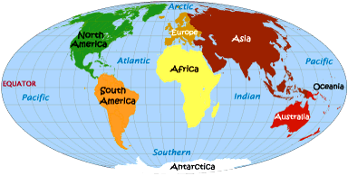

Destinations:
Africa
Asia
Europe
Native America
South America

A 6th Grade Group Music Integration Unit Created By:
Name removed
Mariah Maxwell
Stephanie McCannel
Elisha Summers
Music from Around the World
Music and Social Studies Integration Unit: Sixth Grade

Lesson One – The Evolution of Native American Page 1
Powwow Music. Lesson Plan Format: Traditional. Additional Component: Integrating Social Studies and Montana Indian Education for All Essential Understanding #1 and #2.

Lesson Description: Students will listen to different types of Native American music and discuss their use and the history. Then they will compare the different songs from various tribes.

Lesson Two – African Music and the Clave Rhythm. Page 6
Lesson Plan Format: Multiple Intelligences. Additional Component: Use of Anderson, W.M. and Lawrence, J.E. (2007). Integrating music into the elementary classroom. Belmont: Thomson Schirmer.

Lesson Description: The students will learn about Africa, African music, and learn the clave rhythm.

Lesson Three – Asian Cultures and the Pentatonic Page 10
Scale. Lesson Plan Format: The Learning Cycle. Additional Component: Use of The Music Connection 6: Keyboard Accompaniments (basal series). Morristown, NJ: Silver Burdett Ginn. 1995.

Lesson Description: Through the study of traditional Asian music, students will make discoveries about various Asian cultures and music including those of China and Japan, as well as discover the pentatonic scale.

Lesson Four – Does Culture Affect Music? Lesson Page 15
Plan Format: The Five E’s. Component: Technology.

Lesson Description: Students will use the computer lab to access the website www.sbgmusic.com. There they will read information on Greek music, Irish and Scottish Bagpipes music, Argentina’s music and Peru’s music. Students will choose one European and one South American country and write a short essay comparing and contrasting the information found.
Standard Information: 6th Grade Classroom, Montana State University-Billings

Descriptive Title: The Evolution of Native American Powwow Music

Lesson Description: Students will listen to different types of Native American music and discuss their use and the history. Then they will compare the different songs from various tribes.

Objectives:
- TSW examine the history of powwows.
- TSW identify factors in the changes of powwow music.
- TSW will be able to name at least three types of native songs.

Concepts and/or Key Words and Definitions: Tribal Music – Music specific to certain Native American tribes.
Powwow - A council or meeting with or of Native Americans.
Peyote ceremony – A religious ceremony practiced by Native Americans.
Beat - A steady succession of units of rhythm.¹

Student’s Background Knowledge: Students will have a broad knowledge of Native American history and timelines. Students will have knowledge of American history and timelines. Students will be familiar with the tribes of Montana. Students will have knowledge of beats and rhythms.

Materials and Teaching Aids:
- Portable CD Player
- Powwow music from various tribes, include Montana tribes such as: North Bear, Northern Cheyenne, White Lodge, Crow, Black Lodge, Blackfeet (Kid’s powwow songs), Northern Cree, Cree, and Alberta Canada.
- www.indians.org/articles/powwow.html (Type in name of group and sites with their CDs will come up. Many groups are at local powwows and anyone is allowed to record the drum songs. Go to a powwow and check it out.) Along the left under powwow info are many tabs relating to powwows. Please remember that this is general but not the same for every tribe. Please ask the locals if you want to know, most are willing to share their culture.
- Black Lodge has Kid’s Powwow Songs Volumes I & II for elementary kids.

Classroom Management Suggestions:
- Students will sit in close proximity to the sound system, moving chairs as necessary.

Assessment: The students will be required to summarize in 1 paragraph which piece of music they liked best and why. Also included should be a piece of information that they did not know before, and any questions that did not get answered today. (Questions will be addressed in another lesson.)

Standards:
National Music Standard 6 - Listening to, analyzing, and describing music.
National Music Standard 8 - Understanding relationships between music, the other arts, and disciplines outside the arts.
National Music Standard 9 - Understanding music in relation to history and culture
Montana Art Content Standard 4 - Student analyze characteristics the merits of their work and the work of others
Montana Art Content Standard 5 - Students understand the role of the Arts in society, diverse cultures, and historical periods.
Billings School District #2 Sixth Grade Social Studies Standard 8 - Cultures of America and Europe through time.

Montana Essential Understanding #1
There is a great diversity among the 12 tribal Nations of Montana and their languages, cultures, histories, and governments. Each Nation has a distinct and unique cultural heritage that contributes to modern Montana.

Montana Essential Understanding #2
There is a great diversity among individual American Indians as identity is developed, defined, and redefined by many entities, organizations and people by many entities, organizations and people. There is a continuum of Indian identity ranging from assimilated to traditional and is unique to each individual. There is no generic Indian.

Links Outside this Lesson: History of America with wars, current events in social studies, listening skills and cultural diversity.

Accommodation for Diversity: Joe is a student who has multiple disabilities. He is non-verbal and cognitively delayed; he is mainstreamed for his specials but in a self-contained class for his core subject areas. He is afraid of powwow music. Accommodations for this activity would be to have him stay in the room close to teacher during this activity. Teacher’s aide who accompanies him to class may have to remove him from the room during this activity is student becomes too agitated.

Teaching Model: Madeline Hunter

Anticipatory Set: How many of you have danced? Not professionally. There is a beat to the music right? The moves you do are in rhythm with the beat, not off beat, or you can’t do the same dance for every song right? Native American powwow music is the same. I will be introducing you to powwow music today and show you how native music has progressed through the years.

Goal: Understand how Native American Songs are different from tribe to tribe and how the songs have changed over the years.

Objectives: See above.

Teacher Input: The teacher will guide class discussion and teach students about history of the music and base knowledge of each type of song.
- Read and summarize the powwow history from research (see attached).
Powwow etiquette, the men’s, and women’s dance styles at the following website: http://www.powwows.com/. Click on Teacher and Students Resource. Examine all tabs under powwow info from powwow etiquette to the types of dances. Also, http://www.indians.org/articles/powwow.html

- Begin with war dance song of choice, play 2 different tribes (you may want to try southwest or eastern tribal dances also. Excerpts available on web-Google them.) http://www.emusic.com/album/10931/10931240.html Use warrior song at http://www.fullcir.com/powwow.htm resource if you have money.
Additionally, a CD is available for burning from Mariah.
- Discuss each song as a period in history.
  - War Dance songs were for warriors as they headed into battle against other tribes, then the later U.S. troops. Play Traditional Song.
  - Blackfeet have a courting dance or a friendship dance called the Owl Dance. Play Owl Dance Song.
  - Peyote Meetings are the Native American traditional form of worship and they have a very distinct beat and sound to them. Play Peyote Song.
  - Transportation, intermarriage, and technology have all influenced powwow songs as each tribe has access to the music of other tribes. You may now find Cheyenne drums singing Cree songs and so on.
  - Introduction of new dances such as men’s and women’s fancy dancing, women’s jingle dress, and grass dance have been added to the list of dances that have evolved in the powwow circuit and with them new music. Play Grass Dance Song, Men’s Fancy Dance Song or a Crow Hop for the Jingle Dress.
  - Flags were not needed for individual tribes but this tradition was adopted as assimilation continued to take place. The Northern Cheyenne flag was established in 1997 and later adopted as the official flag of the Northern Cheyenne Nation. Each tribe has its own flag song.
  - Native Americans have fought in every American war and with this comes the honoring of Veterans, most recently Desert Storm and Iraq. Play Blackfeet Vietnam and Desert Storm Honor Song.
  - Other interesting songs with different beats are a double beat, crow hop and sneak up dance.
  - Most recently English words and concepts have made their way into powwow music. See if you recognize these songs. Play Kid’s Powwow Songs.

Check for understanding: The teacher will lead questioning and restate any questions the students have for all the class to hear. Write answers on the board for all to see. Work the room.

Guided Practice: Guided practice is done when we write the order of the songs played on the board. At the end of the lesson, we will add to this list by discussing as a class and writing factors of evolution of powwow music on the board.

Independent Practice: This would be done in an oral fashion by recapping each category after the song through asking questions and checking for understanding.

Closure: By briefly examining Native American music we can begin to understand that just as music from Motown to Hip-Hop has changed, so has Native American music.

Assessment: See Above.

Attachments: Powwow history research
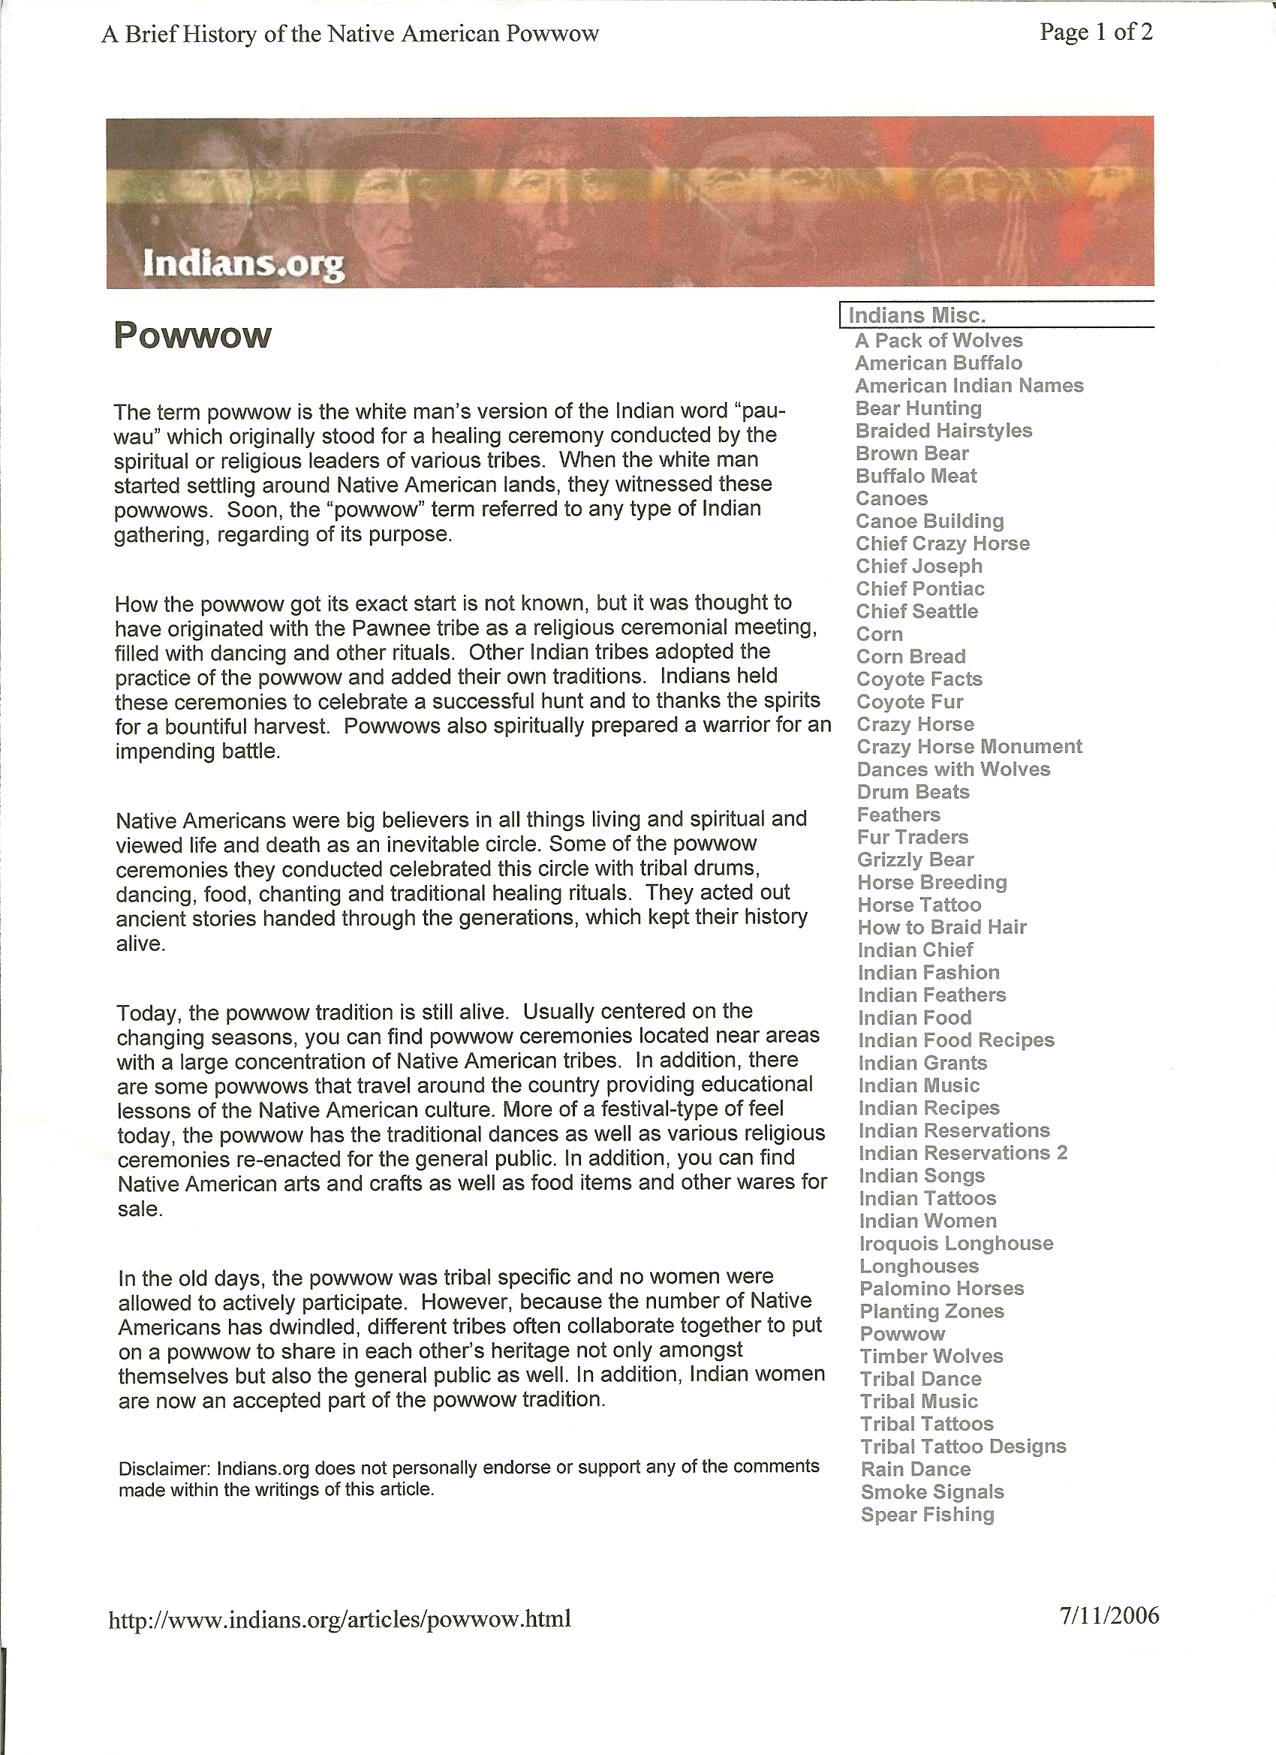
Standard Information: 6th Grade Classroom, Montana State University-Billings

Descriptive Title: African Music and the Clave Rhythm

Lesson Description: The students will learn about Africa, African music, and learn the clave rhythm.

Objectives:
- The students will locate Africa on a map and be able to name five (5) different African countries.
- The students will learn the characteristics of African music
- The students will learn and be able to demonstrate the clave rhythm

Concept(s) and/or Key Words and Definition(s): claves (claw-veys): a pair of cylindrical hardwood sticks that are used as a percussion instrument; a kind of rhythm

Students’ Background Knowledge: The students will be able to read music and understand the concepts of quarter notes, eighth notes, quarter rests, and eighth rest.

Materials and Teaching Aids:
- Dry-erase board and markers.
- A copy of the clave rhythm.
- Claves (one for each student)
- Map of Africa
- Anderson, W.M. and Lawrence, J.E. (2007). Integrating music into the elementary classroom. Belmont: Thomson Schirmer.
- http://www.proteacher.com

Classroom Management Suggestions:
- Do not pass out the claves until all instructions and are given.
- Allow the students about 45 seconds to play with claves so eager hands do not disrupt the lesson.
- Remind students that claves are musical instruments and need to be handled with respect.
- The students should be grouped so that proficient music students are with those of less experience.

Assessment: Students will receive two (2) points for actively participating in this activity. One (1) bonus point may be earned if the student demonstrates the clave rhythm alone.

Standards:
National Music Standard 2 - Performing on instruments, alone and with others, a varied repertoire of music.
National Music Standard 8 - Understanding relationships between music, the other arts, and disciplines outside the arts.
National Music Standard 9 - Understanding music in relation to history and culture
Montana Art Content Standard 1 - Students create, perform/exhibit, and respond in the Arts.
Montana Art Content Standard 2 - Students apply and describe the concepts, structures, and processes in the Arts.
Montana Art Content Standard 5 - Students understand the role of the Arts in society, diverse cultures, and historical periods.
Montana Art Content Standard 6 - Students make connections among the Arts, other subject areas, life, and work.
Montana Social Studies Standard 1 - Students access, synthesize, and evaluate information to communication and apply social studies knowledge to real world situations
Montana Social Studies Standard 3 - Students apply geographic knowledge and skills (e.g., location, place, human/environment interactions, movement, and regions).
Billings School District #2 Sixth Grade Social Studies Standard 8 - Cultures of America and Europe through time.

Links outside this lesson: Students may research how claves are made (what type of wood, how they were developed, etc.) or Latin music that contains the clave rhythm.

Accommodation for Diversity: Students that have visual impairments should be seated toward the front of the classroom or may have their own copy of the clave rhythm.

Teaching Model: Multiple Intelligences
Anticipated Learner Outcome(s): The students will be able to locate Africa on the map and name five (5) of the countries. The students will learn and be able to perform the clave rhythm.

Environmental Consideration: To save paper, the instructor may draw the clave rhythm on the dry-erase board rather than giving each student a copy of the clave rhythm.

Learning Activities:
Musical: Students will be reading and playing music .
Visual/Spatial: Students will be locating five (5) different countries on the map.
Bodily/Kinesthetic: Students will be playing instruments. Students may dance to the clave rhythm.
Intrapersonal: Students will be in groups to practice the clave rhythm and will be working with others.

Lesson Sequence:
- The instructor will present a map of Africa.
- The instructor will ask students to name some of the countries and will have a student scribe write the names of the countries on the dry-erase board.
- The teacher will tell students that much African music is communal and functional; it is often used with dance, games, and ceremonies, such as, weddings and funerals.
- Explain to students that most African slaves did not have any possessions such as toys, they were uneducated (could not read and write) and were most often split up from their families so, all they had was their music and it was extremely important to them.
- The instructor will explain to students that many percussion instruments are used in African music (djembes, talking drums, shekeres, Ghana bells, and claves).
- The teacher will show the students a pair of claves and tell the students that the claves even have their own rhythm that they will get to learn and play.
- The teacher will write the clave rhythm on the board, demonstrate how properly hold the claves, and demonstrate how to play both rhythms. At this point, the student may be encouraged to get up and dance when they “feel” the music.
- The instructor will break students up into groups of 4-5.
- Once the students are in the groups, pass out the claves and allow the students about 45 seconds to play and get a feel for the instruments.
- Give the students between 10-15 minutes to learn the clave rhythm.
- Have the groups perform their rhythms (ask if anyone want to perform a solo for extra credit).
- Tell students that the clave rhythm can be found in many genres of music including Latin music, jazz, reggae, and even heavy metal.
- Complete the lesson by asking students to name some African countries and share a fact about African music that they learned.

Attachments: Clave rhythm sheet
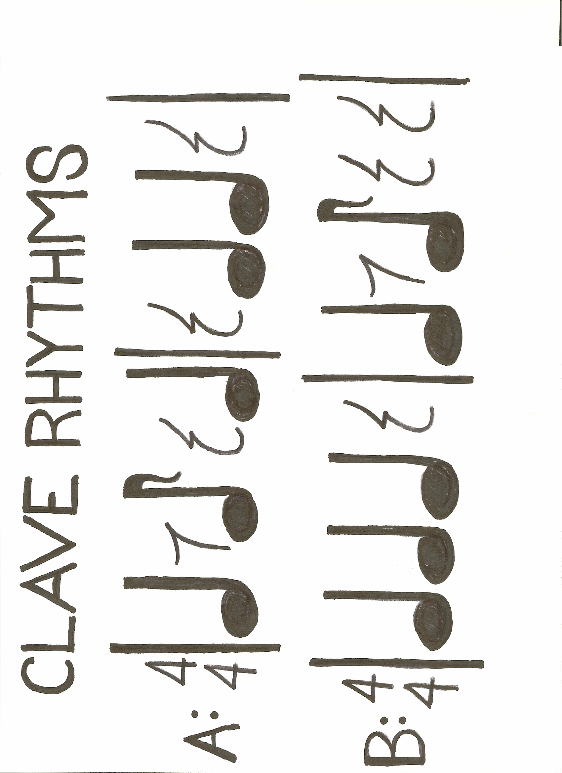
Standard Information: 6th Grade Classroom, Montana State University-Billings

Descriptive Title: Asian Cultures and the Pentatonic Scale

Lesson Description: Through the study of traditional Asian music, students will make discoveries about various Asian cultures and music including those of China and Japan, as well as discover the pentatonic scale.

Objectives:
- TSW locate Asian countries on a map of Asia.
- TSW analyze traditional Asian music to discover the pentatonic scale.
- TSW create 16-24 measures of a melody using the pentatonic scale.

Concepts and/or Key Words and Definitions:
Pentatonic Scale – A five note scale (C, D, F, G, & A) common in traditional Asian music.
Traditional Folk Songs – Songs which are passed from generation to generation by members of specific cultures.

Students’ Background Knowledge: Students will be able to read musical notes well enough to be able to determine which five notes are used in the pentatonic scale. Students will have studied Asian culture, including the differences between Chinese and Japanese culture.

Materials and Teaching Aids:
- Map of Asia
- Sheet music for traditional Japanese song Asadoya.
- Sheet music for traditional Chinese song A Boat on the Lake.
- Dismantled xylophone for each group.
- One page staff paper/ group.

Classroom Management Suggestions:
- Students will be put in groups of four by counting off one through four.
- Each student will be assigned a responsibility (recorder, instrument manager, material gatherer, or clean-up/assignment manager) to perform while working as a group.
- Students should be given 30-45 minutes for the completion of this lesson.

Assessment: Students will be assessed based on the attached rubric. Groups will assess their group members in the areas of contributions, focus on the task, and working with others. The teacher will assess each student on the discovery of the pentatonic scale, locating the country, assembling the xylophone, playing the song, and creating a melody.

Standards:
National Standards for Music Education 5 – Reading and notating music.
National Standards for Music Education 8 – Understanding relationships between music, the other arts, and disciplines outside the arts.
National Standards for Music Education 9 – Understanding music in relation to history and culture.
Montana Art Content Standard 2 – Students apply and describe the concepts, structures, and processes in the Arts.
Montana Art Content Standard 5 –Students understand the role of the Arts in society, diverse cultures, and historical periods.
Montana Art Content Standard 6 – Students make connections among the Arts, other subject areas, life, and work.
Montana Social Studies Content Standard 3 – Students apply geographical knowledge and skills.
Montana Social Studies Content Standard 6 –Students demonstrate and understanding of the impact of human interaction and cultural diversity on societies.
Billings School District #2 Sixth Grade Social Studies Standard 8 - Cultures of America and Europe through time.

Links outside this lesson: This lesson includes the cultural history of Asia, as well as music.

Accommodation for Diversity: Students with hearing impairment will be seated near the speaker when Asian music is played, and assigned the student task of instrument manager. Additionally, all instruction will be provided in writing.

Teaching Model: The Learning Cycle

Interesting Question(s): Has anyone ever heard music from Asia? (If not, play a sample for the class.) Does this music sound the same as music you would hear playing over the radio? What do you think makes the difference in sounds? How can we find out the difference?

Experiment(s)/Experiences: Each group of four students will be provided with a copy of the sheet music to a traditional Asian folk song. Using this sheet music, they will determine the notes used to create the melody found in the song and locate their country on a map of Asia.

Concept Development: Students will rebuild their xylophone using only the notes in the pentatonic scale, and learn to play the song. Additional instruments may be added, if desired.

Application: Each group will develop a new melody using the pentatonic scale.

Attachments: Staff paper, assessment rubric.

Collaborative Work Skills: Asian Music and the Pentatonic Scale
CATEGORY | 4 | 3 | 2 | 1
Contributions | Routinely provides useful ideas when participating in the group and in classroom discussion. A definite leader who contributes a lot of effort. | Usually provides useful ideas when participating in the group and in classroom discussion. A strong group member who tries hard! | Sometimes provides useful ideas when participating in the group and in classroom discussion. A satisfactory group member who does what is required. | Rarely provides useful ideas when participating in the group and in classroom discussion. May refuse to participate.
Focus on the task | Consistently stays focused on the task and what needs to be done. Very self-directed. | Focuses on the task and what needs to be done most of the time. Other group members can count on this person. | Focuses on the task and what needs to be done some of the time. Other group members must sometimes nag, prod, and remind to keep this person on-task. | Rarely focuses on the task and what needs to be done. Lets others do the work.
Working with Others | Almost always listens to, shares with, and supports the efforts of others. Tries to keep people working well together. | Usually listens to, shares, with, and supports the efforts of others. Does not cause "waves" in the group. | Often listens to, shares with, and supports the efforts of others, but sometimes is not a good team member. | Rarely listens to, shares with, and supports the efforts of others. Often is not a good team player.
Discovering the Pentatonic Scale | Students work together to decode the notes of the pentatonic scale. | Students work together to decode the pentatonic scale with errors. | A single member of the group accurately decodes the notes of the pentatonic scale. | A single member of the group decodes the notes of the pentatonic scale incorrectly.
Locating the Country | Students work together to accurately locate their country. | A single student accurately locates the country. | Students work together, but are unable to accurately locate the country. | A single student is unable to locate the country.
Assembling the Xylophone | Students assemble the xylophone correctly according to the pentatonic scale by working cooperatively. | Students assemble the xylophone partially correctly by working together. | Students to not attempt to assemble the xylophone as a group, but allow an individual to work alone and assemble the xylophone. | Students do not make an attempt to assemble to xylophone, but rely on members of another group to do it for them.
Playing the Song | Each group member can accurately play the folk song using at least two instruments. | Each group member can accurately play the folk song using the xylophone. | Each group member can accurately play half of the folk song. | Some group members can play parts of the folk song.
Creating a Melody | Students work together to create a melody that is at least 24 measures long, which accurately uses the pentatonic scale. | Students work together to create a melody that is at least 16 measures long, which accurately uses the pentatonic scale. | Students work together to create a melody that is at least 24 measures long, but does not accurately use the pentatonic scale. | Students work together to create a melody that is at least 16 measures long, but does not accurately use the pentatonic scale.
Standard Information: 6th Grade Classroom, Montana State University-Billings

Descriptive Title: Does Culture Affect Music?

Lesson Description: Students will use the computer lab to access the website www.sbgmusic.com. There they will read information on Greek music, Irish and Scottish Bagpipes music, Argentina’s music and Peru’s music. Students will choose one European and one South American country and write a short essay comparing and contrasting the information found.

Objectives:
- TSW begin to understand the effect that culture has on music.
- TSW use a computer to research information.
- TSW comprehend information read.
- TSW write an essay using proper grammar and punctuation.

Concept(s) and/or Key Words and Definitions: A country’s music is affected by the culture(s) living in the country.

Students’ Background Knowledge: Students will need to shown locations of Greece, Ireland, Scotland, Peru, and Argentina on globe or classroom map. Students need to be shown how to accurately take notes on information read on computer.

Materials and Teaching Aids:
- Computer lab needs to be reserved.
- pencil and paper
- Greek music available from www.library.thinkquest.org/cr0210200.
- Scottish music from CD: Highland Pipes and Drums (Producer Legacy International.)
- Celtic music from CD: Enya Shepherd Moons (Producer Nicky Ryan).
- South American music from website: www.historic/museam.org.

Classroom Management Suggestions:
- Students will listen to music before going to computer lab or picking up computers if it is a mobile lab.
- Students will be reminded to be careful with the computers.
- Students will be instructed to only go to web pages written on the board.

Assessment: Students’ final essay will inform teacher about the students’ understanding of the information read. It will also show students’ weaknesses with punctuation and grammar. Essay will be worth 20 points

Standards:
National Music Standard 6 - Understanding music in relation to history and culture.
State Music Standard 5 - Students understand the role of Arts in society, diverse cultures, and historical periods.
Montana Technology Standard 1 - Students demonstrate an understanding of the basic operations of technologies.
National Technology Standard 1- Basic Operations and Concepts.
National Technology Standard 5 - Technology Research Tools.
Montana Social Studies Standard 6 - Students demonstrate an understanding of the impact of human interaction and cultural diversity on societies.
Billings School District #2 Sixth Grade Social Studies Standard 8 - Cultures of America and Europe through time.

Links outside this lesson: Social Studies, Technology

Accommodation for Diversity: If necessary, another student or teacher assistant will help students unable to see, or hear the computer. Any students unable to use the computer will be helped by another student.

Teaching Model: 5 E’s
Engage: Teacher will play music from Greece, South America, Scotland, and Ireland. The teacher will explain that the students are going to use the computers to research the effect of culture on music.

Explore: Students will be instructed to go to web page written on the board (www.sbgmusic.com). They will then be instructed to click on “resource articles”. Students may choose between Greek music or Celtic bagpipes. They must also choose between Argentina and Peru. Once a choice is made the student is to review information for both chosen countries. The student will then take notes on differences and/or similarities of the music from each country. If necessary, the teacher will assign countries.

Explain: Student will decide what is different or similar about the information given on both countries. The student will write these conclusions down for use in the essay.

Elaborate: Students use the information gathered to write rough draft of short essay on similarities and differences of two countries chosen.

Evaluate: The final draft will be an essay. It will be turned in and graded on punctuation, accuracy of information, and students understanding of the information.

Attachments: None

Definition retrieved from http://dictionary.reference.com
The Music Connection 6: Keyboard Accompaniments (basal series). Morristown, NJ: Silver Burdett Ginn. 1995. Page 76.
The Music Connection 6: Keyboard Accompaniments (basal series). Morristown, NJ: Silver Burdett Ginn. 1995. Page 78.

